What is Computer Network?

A **computer network** is a set of devices connected through links. A node can be computer, printer, or any other device capable of sending or receiving the data. The links connecting the nodes are known as communication channels.

A **computer network** is a system in which multiple computers are connected to each other to share information and resources.

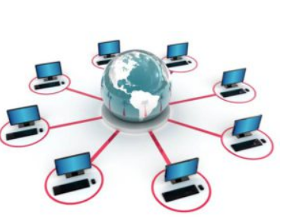

## Components/Devices of Computer Network:

Computer network components are the major parts which are needed to install the software. Some important network components are **NIC**, **switch**, **cable**, **hub**, **router**, and **modem**. Depending on the type of network that we need to install, some network components can also be removed. For example, the wireless network does not require a cable.

Following are the major components required to install a network:

## 

## Major components of a computer network are:

### NIC(Network interface card)

NIC is a device that helps the computer to communicate with another device. The network interface card contains the hardware addresses, the data-link layer protocol use this address to identify the system on the network so that it transfers the data to the correct destination.

There are two types of NIC: wireless NIC and wired NIC.

* **Wireless NIC:** All the modern laptops use the wireless NIC. In Wireless NIC, a connection is made using the antenna that employs the **radio wave technology**.
* **Wired NIC:** Cables use the **wired NIC** to transfer the data over the medium.

## 

### Hub

Hub is a central device that splits the network connection into multiple devices. When computer requests for information from a computer, it sends the request to the Hub. Hub distributes this request to all the interconnected computers.

## In networking, a hub is a device that links multiple computers and devices together. Hubs can also be referred to as repeaters or concentrators, and they serve as the center of a local area network (LAN).

## 

### Switches

Switch is a networking device that groups all the devices over the network to transfer the data to another device. A switch is better than Hub as it does not broadcast the message over the network, i.e., it sends the message to the device for which it belongs to. Therefore, we can say that switch sends the message directly from source to the destination.

Switches have many ports, and when data arrives at any port, the destination address is examined first and some checks are also done and then it is processed to the devices. Different types of communication are supported here like unicast, multicast, and broadcast communication.

**Features of Network Switches**

* It operates in the Data Link Layer in the [OSI Model](https://www.geeksforgeeks.org/layers-of-osi-model/).
* It performs error checking before forwarding data.
* It transfers the data only to the device that has been addressed.
* It operates in full duplex mode.
* It allocates each [LAN](https://www.geeksforgeeks.org/lan-full-form/) segment to a limited bandwidth.
* It uses Unicast (one-to-one), multicast (one-to-many), and broadcast (one-to-all) transmission modes.
* Packet-switching techniques are used to transfer data packets from source to destination.
* Switches have a more significant number of ports.

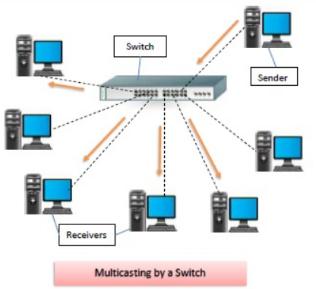

**Bridge**

 Bridge is a [network device](https://www.shiksha.com/online-courses/articles/network-devices-in-computer-networks-and-its-types/) that connects multiple subnetworks to create a single network. It provides interconnection with other computer networks that use the same protocol. Through a bridge, multiple LANs can be connected to form a larger and extended [LAN](https://www.shiksha.com/online-courses/articles/lan-local-area-network/).  A bridge is a repeater, with add on the functionality of filtering content by reading the MAC addresses of the source and destination. It is also used for interconnecting two LANs working on the same protocol

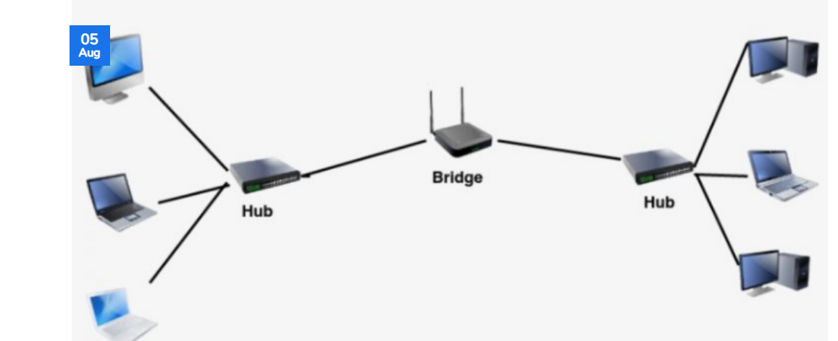

### Router

Router is a device that connects the LAN to the internet. The router is mainly used to connect the distinct networks or connect the internet to multiple computers.

A router is a device like a switch that routes data packets based on their IP addresses. The router is mainly a Network Layer device. Routers normally connect LANs and WANs and have a dynamically updating routing table based on which they make decisions on routing the data packets. The router divides the broadcast domains of hosts connected through it.

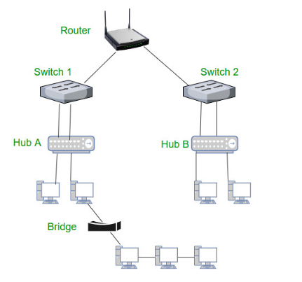

### ****Modems****

A modem (short for modulator-demodulator) is a device that converts digital signals into analog signals of different frequencies and transmits them to a modem at the receiving location. These signals From the modem can be transmitted over telephone lines, cable systems, or other communication mediums. A modem also works to convert incoming analog signals back into digital data.

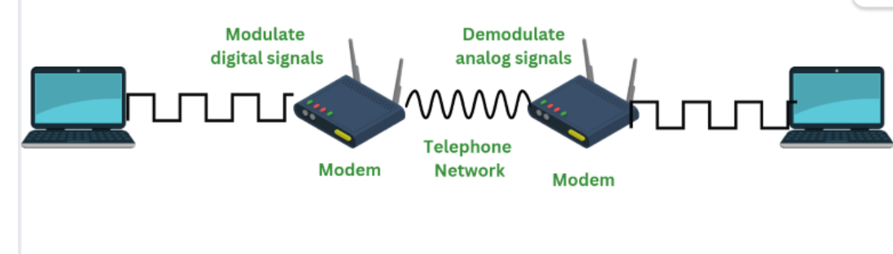

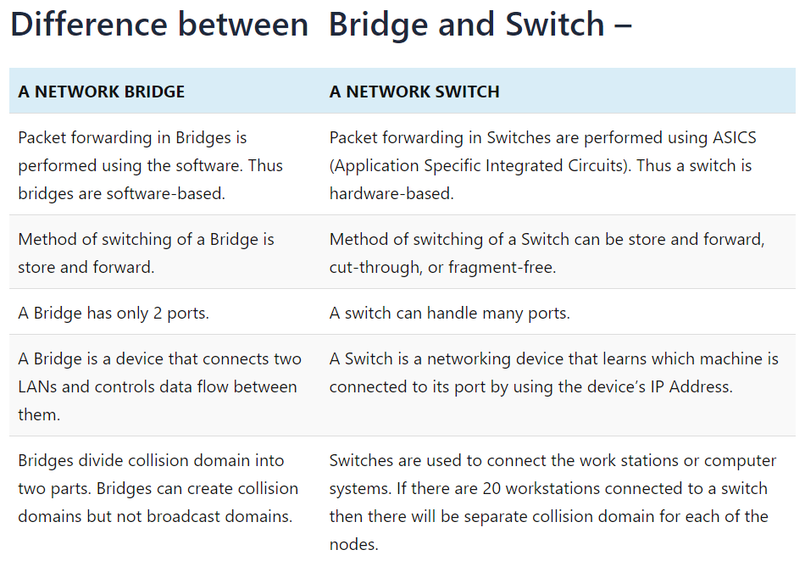

### Cables and connectors

Cable is a transmission media that transmits the communication signals. **There are three types of cables:**

* **Twisted pair cable:** It is a high-speed cable that transmits the data over **1Gbps** or more.
* **Coaxial cable:** Coaxial cable resembles like a TV installation cable. Coaxial cable is more expensive than twisted pair cable, but it provides the high data transmission speed.
* **Fibre optic cable:** Fibre optic cable is a high-speed cable that transmits the data using light beams. It provides high data transmission speed as compared to other cables. It is more expensive as compared to other cables, so it is installed at the government level.

Uses Of Computer Network

* **Resource sharing:** Resource sharing is the sharing of resources such as programs, printers, and data among the users on the network without the requirement of the physical location of the resource and user.
* **Server-Client model:** Computer networking is used in the **server-client model**. A server is a central computer used to store the information and maintained by the system administrator. Clients are the machines used to access the information stored in the server remotely.
* **Communication medium:** Computer network behaves as a communication medium among the users. For example, a company contains more than one computer has an email system which the employees use for daily communication.
* **E-commerce:** Computer network is also important in businesses. We can do the business over the internet. For example, amazon.com is doing their business over the internet, i.e., they are doing their business over the internet.

# Computer Network Architecture

Computer Network Architecture is defined as the physical and logical design of the software, hardware, protocols, and media of the transmission of data. Simply we can say that how computers are organized and how tasks are allocated to the computer.

**The two types of network architectures are used:**

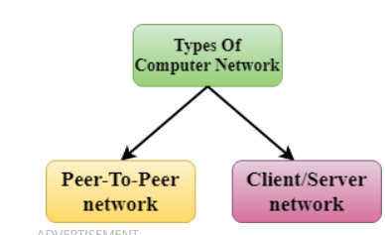

Peer-To-Peer network

* Peer-To-Peer network is a network in which all the computers are linked together with equal privilege and responsibilities for processing the data.
* Peer-To-Peer network is useful for small environments, usually up to 10 computers.
* Peer-To-Peer network has no dedicated server.
* Special permissions are assigned to each computer for sharing the resources, but this can lead to a problem if the computer with the resource is down.

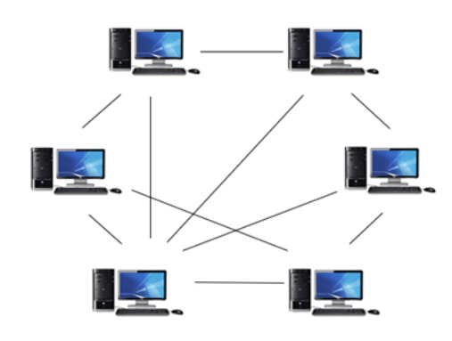

### Advantages Of Peer-To-Peer Network:

* It is less costly as it does not contain any dedicated server.
* If one computer stops working but, other computers will not stop working.
* It is easy to set up and maintain as each computer manages itself.

### Disadvantages Of Peer-To-Peer Network:

* In the case of Peer-To-Peer network, it does not contain the centralized system . Therefore, it cannot back up the data as the data is different in different locations.
* It has a security issue as the device is managed itself.

Client/Server Network

* Client/Server network is a network model designed for the end users called clients, to access the resources such as songs, video, etc. from a central computer known as Server.
* The central controller is known as a **server** while all other computers in the network are called **clients**.
* A server performs all the major operations such as security and network management.
* A server is responsible for managing all the resources such as files, directories, printer, etc.
* All the clients communicate with each other through a server. For example, if client1 wants to send some data to client 2, then it first sends the request to the server for the permission. The server sends the response to the client 1 to initiate its communication with the client 2.

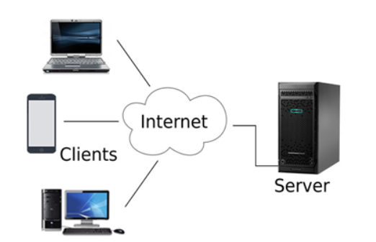

### Advantages Of Client/Server network:

* A Client/Server network contains the centralized system. Therefore we can back up the data easily.
* A Client/Server network has a dedicated server that improves the overall performance of the whole system.
* Security is better in Client/Server network as a single server administers the shared resources.
* It also increases the speed of the sharing resources.

### Disadvantages Of Client/Server network:

* Client/Server network is expensive as it requires the server with large memory.
* A server has a Network Operating System(NOS) to provide the resources to the clients, but the cost of NOS is very high.
* It requires a dedicated network administrator to manage all the resources.

# Computer Network Types

A computer network is a group of computers linked to each other that enables the computer to communicate with another computer and share their resources, data, and applications.

A computer network can be categorized by their size. A **computer network** is mainly of **four types**:

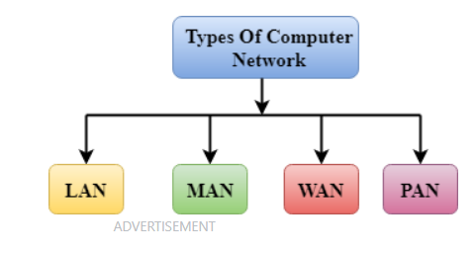

* AN(Local Area Network)
* PAN(Personal Area Network)
* MAN(Metropolitan Area Network)
* WAN(Wide Area Network)

LAN(Local Area Network)

* Local Area Network is a group of computers connected to each other in a small area such as building, office.
* LAN is used for connecting two or more personal computers through a communication medium such as twisted pair, coaxial cable, etc.
* It is less costly as it is built with inexpensive hardware such as hubs, network adapters, and ethernet cables.
* The data is transferred at an extremely faster rate in Local Area Network.
* Local Area Network provides higher security.

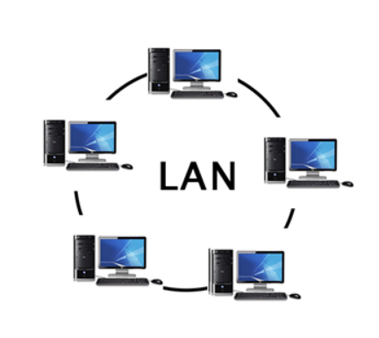

PAN(Personal Area Network)

* Personal Area Network is a network arranged within an individual person, typically within a range of 10 meters.
* Personal Area Network is used for connecting the computer devices of personal use is known as Personal Area Network..
* Personal Area Network covers an area of **30 feet**.
* Personal computer devices that are used to develop the personal area network are the laptop, mobile phones, media player and play stations.

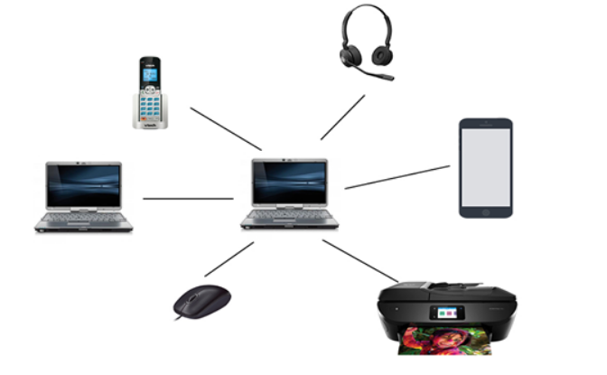

MAN(Metropolitan Area Network)

* A metropolitan area network is a network that covers a larger geographic area by interconnecting a different LAN to form a larger network.
* Government agencies use MAN to connect to the citizens and private industries.
* In MAN, various LANs are connected to each other through a telephone exchange line.
* The most widely used protocols in MAN are RS-232, Frame Relay, ATM, ISDN, OC-3, ADSL, etc.
* It has a higher range than Local Area Network(LAN).

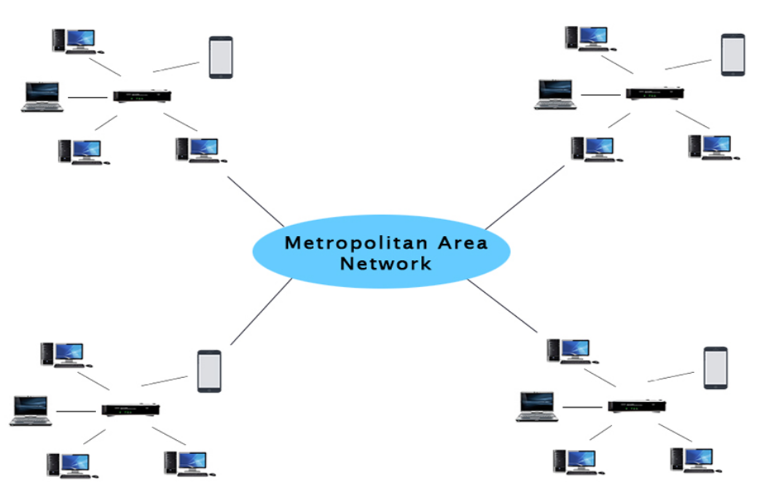

### Uses Of Metropolitan Area Network:

* MAN is used in communication between the banks in a city.
* It can be used in an Airline Reservation.
* It can be used in a college within a city.
* It can also be used for communication in the military.

WAN(Wide Area Network)

* A Wide Area Network is a network that extends over a large geographical area such as states or countries.
* A Wide Area Network is quite bigger network than the LAN.
* A Wide Area Network is not limited to a single location, but it spans over a large geographical area through a telephone line, fibre optic cable or satellite links.
* The internet is one of the biggest WAN in the world.
* A Wide Area Network is widely used in the field of Business, government, and education.

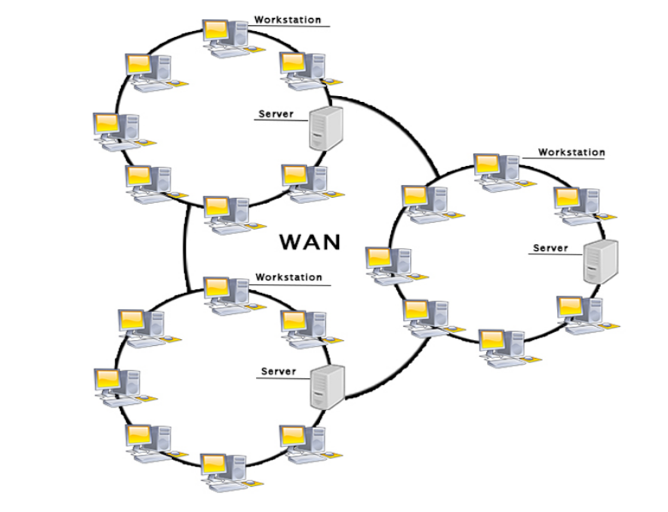

## Types Of Internetwork:

1. **Extranet:** An extranet is a communication network based on the internet protocol such as **Transmission Control protocol** and **internet protocol**. It is used for information sharing. The access to the extranet is restricted to only those users who have login credentials. An extranet is the lowest level of internetworking. It can be categorized as **MAN**, **WAN** or other computer networks. An extranet cannot have a single **LAN**, atleast it must have one connection to the external network.

2. **Intranet:** An intranet is a private network based on the internet protocol such as **Transmission Control protocol** and **internet protocol**. An intranet belongs to an organization which is only accessible by the **organization's employee** or members. The main aim of the intranet is to share the information and resources among the organization employees. An intranet provides the facility to work in groups and for teleconferences.